**DATA SCIENCE**

**STATISTICS**

**ASSIGNMENT-4**

**EXERCISE 1.**Use the data in the table below to generate a scatter plot, calculate Pearson’s correlation, and interpret the relationship between two variables.

| **X** | **Y** |
| --- | --- |
| 0 | 88 |
| 6 | 52 |
| 4 | 64 |
| 1 | 60 |
| 5 | 54 |
| 3 | 78 |
| 4 | 40 |

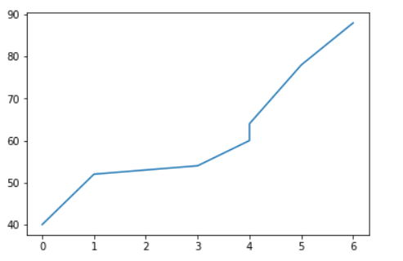

**Pearson’s correlation:**

**np.corrcoef(x,y)[0,1]**

-0.6736717993982944

Relationship Between Two Variables:

Pearson’s correlation = r and it is strong negative relationship between two variables cause of r valuable is closer to -1

**EXERCISE 2.**In some cases we, data analysts, make calculations using online calculators. Answer the following questions using the online calculator available at this link: [Normal Distribution Calculator](http://onlinestatbook.com/2/calculators/normal_dist.html)

1. The heights of male students in a particular town are normally distributed with a mean of 65 inches and a standard deviation of 1.7. What percentage of these students is taller than 66.7 inches?

Student taller than 66.7 inches percentage is about %25

1. A data set was created by asking 300 students about their weights. The mean is 60 kg. standard deviation is 8 kg. How many students weighed more than 52 kg and less than 68 kg?

178 students weighed are more than 52 kg and less than 68 kg.

**EXERCISE 3.** The last 10 game results between LA Lakers and LA Clippers are given in the table below. Draw two boxplots for the points scored by these 2 teams and answer the following questions.

|  |  |  |
| --- | --- | --- |
| **Date** | **LA Lakers** | **LA Clippers** |
| July 31, 2020 | 103 | 101 |
| March 8, 2020 | 112 | 103 |
| December 26, 2019 | 106 | 111 |
| October 23, 2019 | 102 | 112 |
| July 7, 2019 | 87 | 93 |
| April 6, 2019 | 122 | 117 |
| March 5, 2019 | 105 | 113 |
| February 1, 2019 | 123 | 120 |
| December 29, 2018 | 107 | 118 |
| October 7, 2018 | 87 | 103 |

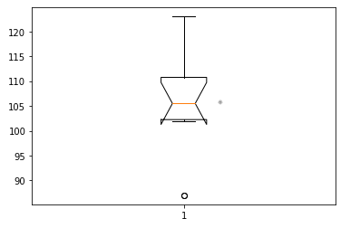

1. Which team has a greater median, Lakers or Clippers?

Clippers mean = 109.1 >Lakers mean = 105.4

1. Which team has greater IQR, Lakers or Clippers?

Clippers IQR = 13 > Lakers IQR = 8.5

1. Which team has a higher percentage of scores above its median?

Clippers median = 111.5 > Clippers mode is 103

Lakers median = 105.5 > Lakers mode is 87